**AWS NOTES**

1. **What is AWS introduction?**

In 2006, **Amazon Web Services** (**AWS**) began offering IT infrastructure services to businesses as web services—now commonly known as cloud computing. One of the key benefits of cloud computing is the opportunity to replace upfront capital infrastructure expenses with low variable costs that scale with your business.

1. **What is Cloud Computing introduction?**

Cloud Computing is the delivery of computing services such as servers, storage, databases, networking, software, analytics, intelligence, and more, over the Cloud (Internet). Cloud Computing provides an alternative to the on-premises datacenter.

1. **What is cloud computing?**

Cloud computing is the on-demand delivery of IT resources over the Internet with pay-as-you-go pricing. Instead of buying, owning, and maintaining physical data centers and servers, you can access technology services, such as computing power, storage, and databases, on an as-needed basis from a cloud provider like Amazon Web Services (AWS).

* **Three key words**

1. On- demand (whenever /whatever we need, we can get immediately)
2. Scalable (increase decrease the configuration as per requirement )
3. Pay only whatever you use.
4. **What is AWS global infrastructure?**

The AWS Global Cloud Infrastructure is the most secure, extensive, and reliable cloud platform, offering over 200 fully featured services from data centers globally.

1. **What is the proper structure of an AWS global infrastructure?**

The AWS Global Infrastructure consists of multiple geographical locations which are called Regions. AWS Regions are divided up in Availability Zones which consist of one or more psychically separated data centers.

1. **What is region in AWS?**

AWS has the concept of a Region, which is a physical location around the world where we cluster data centers. We call each group of logical data centers an Availability Zone. Each AWS Region consists of multiple, isolated, and physically separate AZ's within a geographic area.

1. What is availability zone in AWS?

Availability Zones are distinct locations within an AWS Region that are engineered to be isolated from failures in other Availability Zones. They provide inexpensive, low-latency network connectivity to other Availability Zones in the same AWS Region. Important. Each region is completely independent.

1. What are advantages of cloud?

Cloud infrastructures support environmental proactivity, powering virtual services rather than physical products and **hardware**, and cutting down on paper waste, improving energy **efficiency**, and (given that it allows employees access from anywhere with an internet connection) reducing commuter-related **emissions**.

1. Why we should learn AWS?

These numbers show that Cloud Computing skills, precisely **AWS** skills, are in high demand and will continue to be for a long time to come. For IT professionals, **learning AWS** is a reliable way to advance their career and companies are ready to pay top-dollar for specialists in the increasingly ubiquitous **AWS** platform.

1. What are the types of cloud computing?

Types of cloud computing

The three main types of cloud computing include Infrastructure as a Service, Platform as a Service, and Software as a Service. Each type of cloud computing provides different levels of control, flexibility, and management so that you can select the right set of services for your needs.

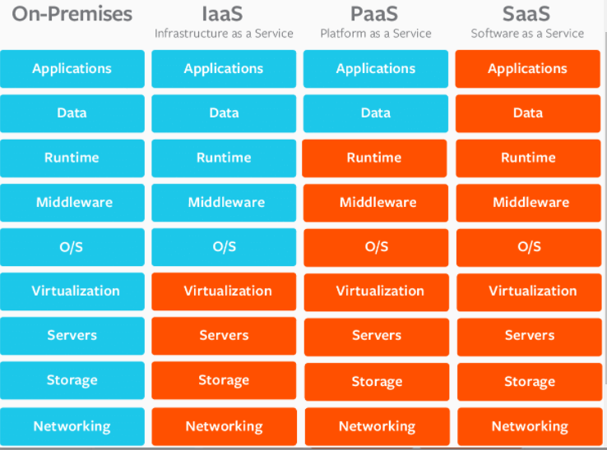

## **The Key Differences between On-Premise, SaaS, PaaS, IaaS**

Not so long ago, all of a company’s IT systems were on-premise, and clouds were just white fluffy things in the sky.

Now, you can utilize the Cloud platform for nearly all your systems and processes.

SaaS, PaaS, and IaaS are simply three ways to describe how you can use the cloud for your business.

1. IaaS: cloud-based services, pay-as-you-go for services such as storage, networking, and virtualization.
2. PaaS: hardware and software tools available over the internet.
3. SaaS: software that’s available via a third-party over the internet.
4. On-premise: software that’s installed in the same building as your business.
5. What is on premise?

An on-**premise server** is a physical, on-site **server** that a company must manage and maintain individually.

1. What is meant by IaaS in cloud computing?

Infrastructure as a service (**IaaS**) is a **cloud computing** offering in which a vendor provides users access to **computing** resources such as storage, networking, and servers. Organizations use their own platforms and applications within a service provider's infrastructure.

Here the cloud services providers offer database, web servers, application servers, messaging services, storage, network, and more to their customers as a service, and customers pay them as per use.

1. What is meant by PaaS in cloud computing?

Platform as a services Pass provides customers with an on-demand environment for testing developing and delivering applications (code) in the cloud.

It provides development tool. For example application server (java, .net framework) and database server (MySQL, Oracle)

It makes it easy for developers to quickly create web or mobile application and deliver them to the market.

1. What is meant by SaaS in cloud computing?

Software as a services

SaaS provides you with a complete product that is run and managed by the service provider. In most cases, people referring to SaaS are referring to end-user applications (such as web-based email). With a SaaS offering, you don’t have to think about how the service is maintained or how the underlying infrastructure is managed. You only need to think about how you will use that particular software.

**AMAZON EC2**

1. What is EC2 in AWS?

Amazon Elastic Compute Cloud (Amazon **EC2**) provides scalable computing capacity in the **Amazon Web Services** (**AWS**) Cloud. ... You can use Amazon **EC2** to launch as many or as few virtual servers as you need, configure security and networking, and manage storage.

**(Or)**

Amazon Elastic Compute Cloud (Amazon **EC2**) is a web service that provides secure, resizable compute capacity in the cloud. It is designed to make web-scale cloud computing easier for developers. ... It provides you with complete control of your computing resources and lets you run on Amazon's proven computing environment.

1. What EC2 means?

Amazon Elastic Compute Cloud (EC2) is a part of Amazon.com's cloud-computing platform, Amazon Web Services (AWS) that allows users to rent virtual computers on which to run their own computer applications

1. What is benefit of ec2?

Essentially, Amazon **EC2** provides the same level of access and control as a physical server operated locally in the office. Compute instances are easily managed through the Amazon **EC2** web interface which allows users to scale up or down, boot instances, and configure processor settings with a few clicks of a mouse.

## **AMI (Amazon Machine Image)**

1. **What is AMI?**

An Amazon Machine Image (**AMI**) provides the information required to launch an instance. You must specify an **AMI** when you launch an instance. You can launch multiple instances from a single **AMI** when you need multiple instances with the same configuration.

1. **What is used for AMI?**

An Amazon Machine Image (**AMI**) provides the information required to launch an instance. You must specify an **AMI** when you launch an instance. You can launch multiple instances from a single **AMI** when you need multiple instances with the same configuration.

* AMI provides the information to launch the EC2 instance.
* AMI includes the pre-configured templates of the operating system that runs on the AWS
* Users can launch multiple instances with the same configuration from a single AMI

1. What is security group in AWS?

A **security group** acts as a virtual firewall for your **EC2** instances to control incoming and outgoing traffic. ... If you don't specify a **security group**, Amazon **EC2** uses the default **security group**. You can add rules to each **security group** that allow traffic to or from its associated instances.

1. Security Groups deals with Ports.
2. Port is like a door to your Instance.
3. We have total 0 - 65535 number of ports are there. Each port will have both incoming and outgoing options.
4. All these ports are dedicated for some special purpose
5. Most Important ports are RDP (3389), SSH (22), HTTP (80) and HTTPS (443).
6. RDP port is a dedicated port for windows. If you want to access any windows server, you need to open RDP port of that server. Through that port only we can access windows server. If it is Linux, then we have to open SSH (22) Port.
7. Remaining ports will be discussed in next classes.

## **Key:-**

Key pair is just like a password. But here it is a file. By default we get .pem

(Privacy-Enhanced Mail) key. To access windows instance, we need to convert that

.pem into Password. Because, windows instance supports password only.

* Best practice is after finishing work, either terminate or stop your Instance. If we stop your instance, we can start at any time. But if we terminate instance, we can’t start. Termination means losing instance forever.

**Amazon VPC**

* 1. Which are components of Amazon VPC?

**AWS VPC is made up of several networking components, as shown in the following figure; some of them are as follows:**

* Subnets.
* Elastic **network** interfaces.
* **Route tables**.
* **Internet gateways**.
* Elastic IP addresses.
* VPC endpoints.
* NAT.
* VPC **peering**.
  1. What are VPCS in AWS?

Amazon Virtual Private Cloud (Amazon **VPC**) is a service that lets you launch **AWS** resources in a logically isolated virtual network that you define. ... You can use both IPv4 and IPv6 for most resources in your virtual private cloud, helping to ensure secure and easy access to resources and applications

* 1. What is Amazon VPC used for?

**Amazon VPC** enables you to build a virtual network in the **AWS** cloud - no VPNs, hardware, or physical datacenters required. You can define your own network space, and control how your network and the **Amazon EC2** resources inside your network are exposed to the Internet.

VPC networking components

You can use the following components to configure networking in your VPC.

* [Internet gateways](https://docs.aws.amazon.com/vpc/latest/userguide/VPC_Internet_Gateway.html)
* [Egress-only internet gateways](https://docs.aws.amazon.com/vpc/latest/userguide/egress-only-internet-gateway.html)
* [Carrier gateways](https://docs.aws.amazon.com/vpc/latest/userguide/Carrier_Gateway.html)
* [NAT devices for your VPC](https://docs.aws.amazon.com/vpc/latest/userguide/vpc-nat.html)
* [DHCP options sets](https://docs.aws.amazon.com/vpc/latest/userguide/VPC_DHCP_Options.html)
* [Using DNS with your VPC](https://docs.aws.amazon.com/vpc/latest/userguide/vpc-dns.html)
* [Prefix lists](https://docs.aws.amazon.com/vpc/latest/userguide/managed-prefix-lists.html)